Data cleaning and transformation in Power Query Editor

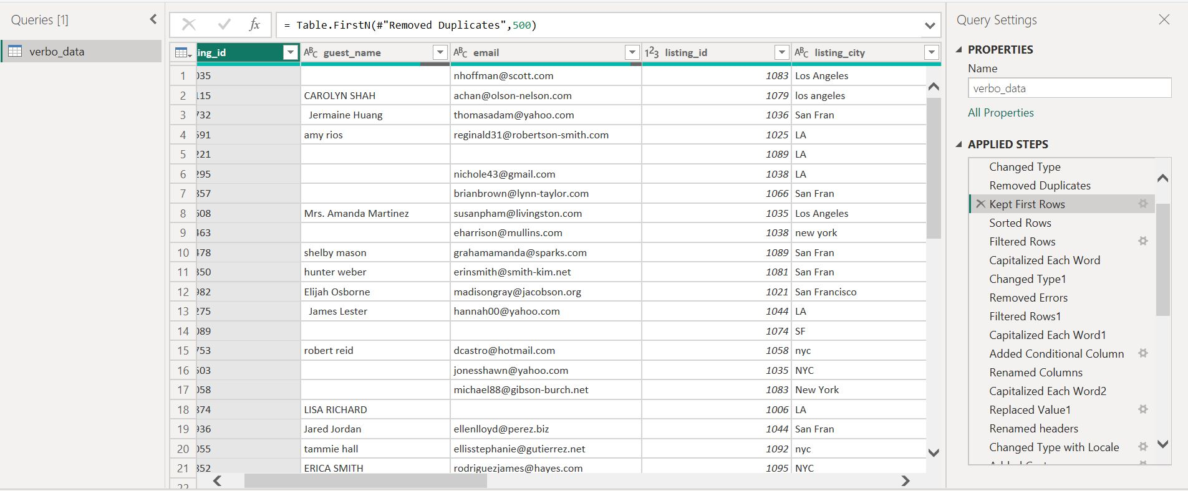

1.Kept first 500 rows

2.Remove duplicates in Booking id column and changed the data type into text.

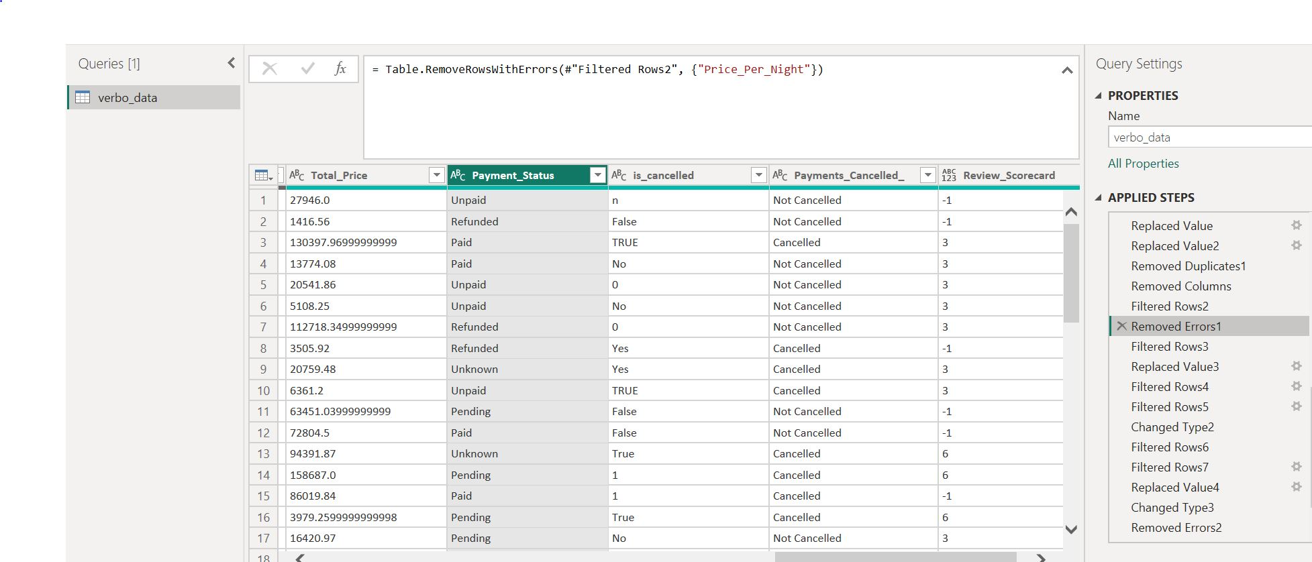

1.Removed the errors in payment status like null,blanks,and N/A

2.Replace values with refunded for N/A and Unknown for blanks

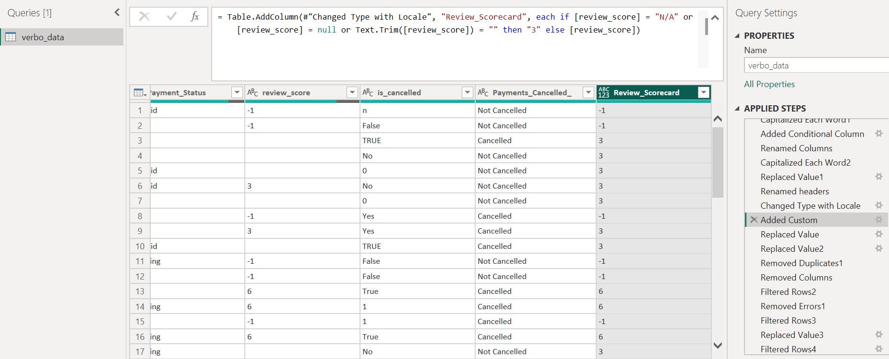

1.Added a custom column for review scorecard and using statistics find a average and replace the value with blank cells and cleaned the null values.=if[review score]=”N/A” or [reveiw score]=null or text.trim([review score])=””then”3”else [review score].

2.changed the data type into decimal number.

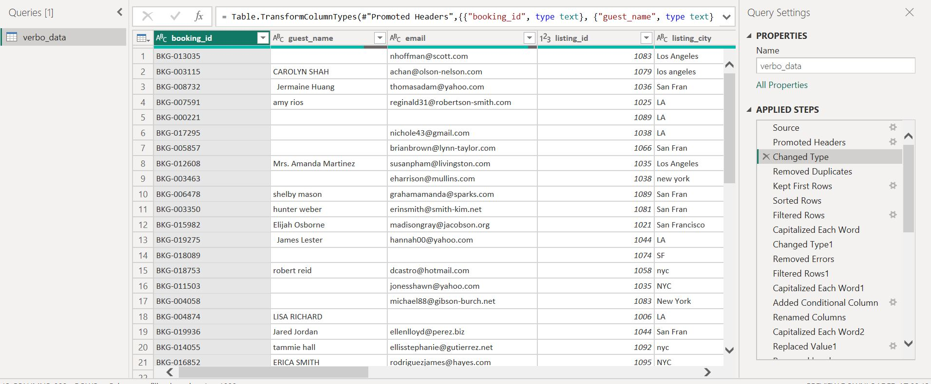

1.changed the data type text for Booking id and sort the rows.

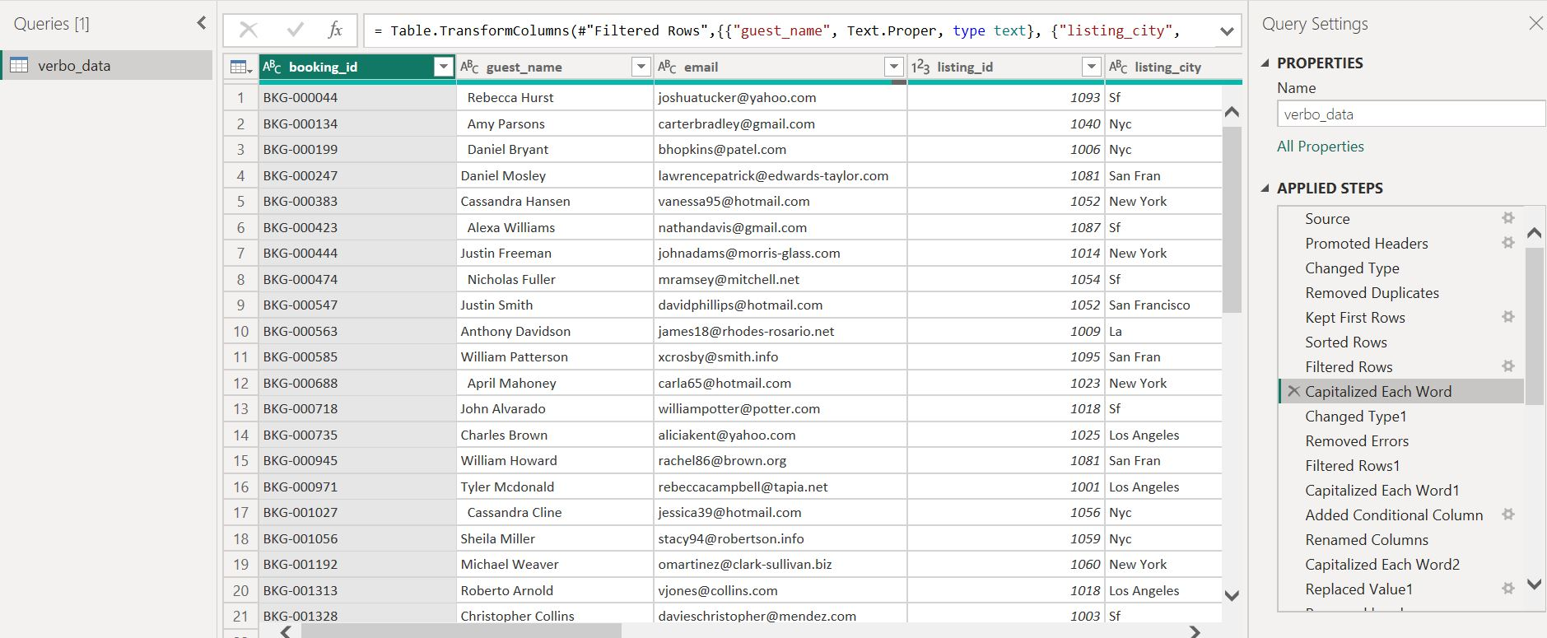

1.Capitalize the each word in all column and filtered rows and cleared the null and n/a and errors values removed.

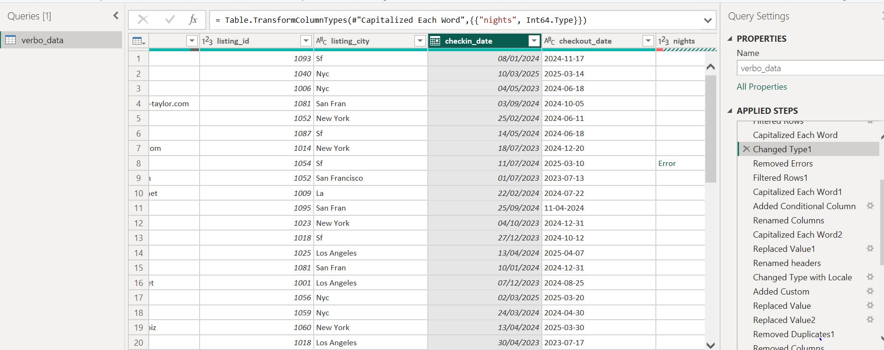

1.Changed the datetype for checkin date using locale.

2.Removed errors and nulls

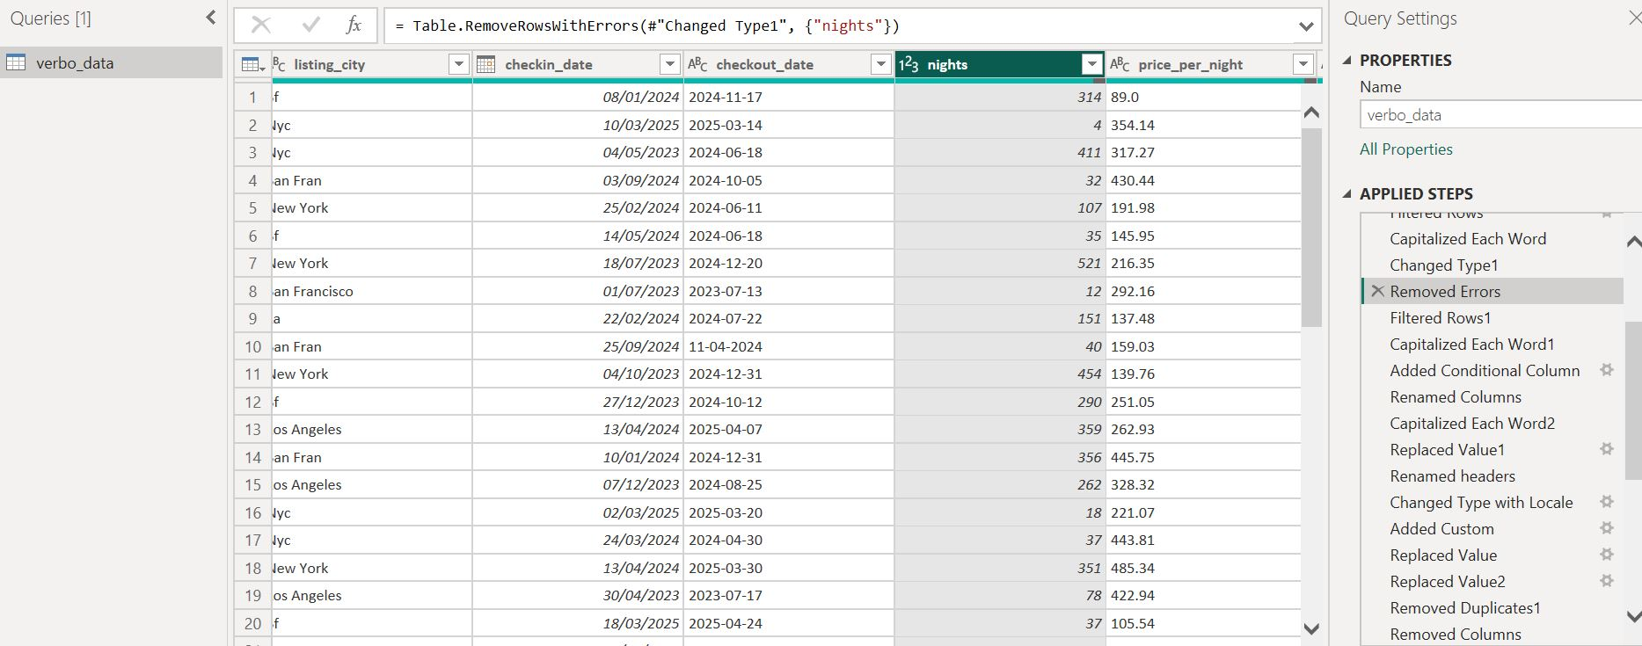

1.Removed errors and remove empty spaces and remove null values in night column

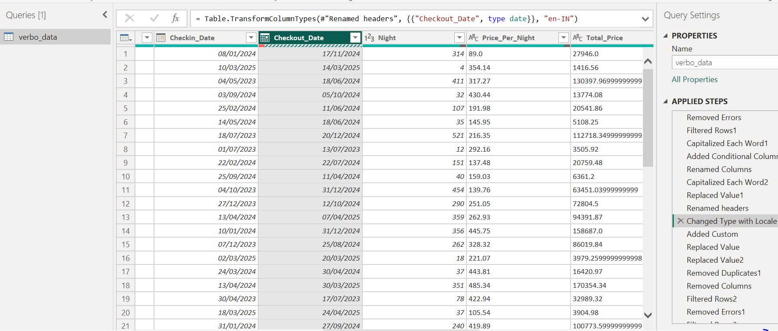

1.Changed the data type for checkout date using locale in indian date format.

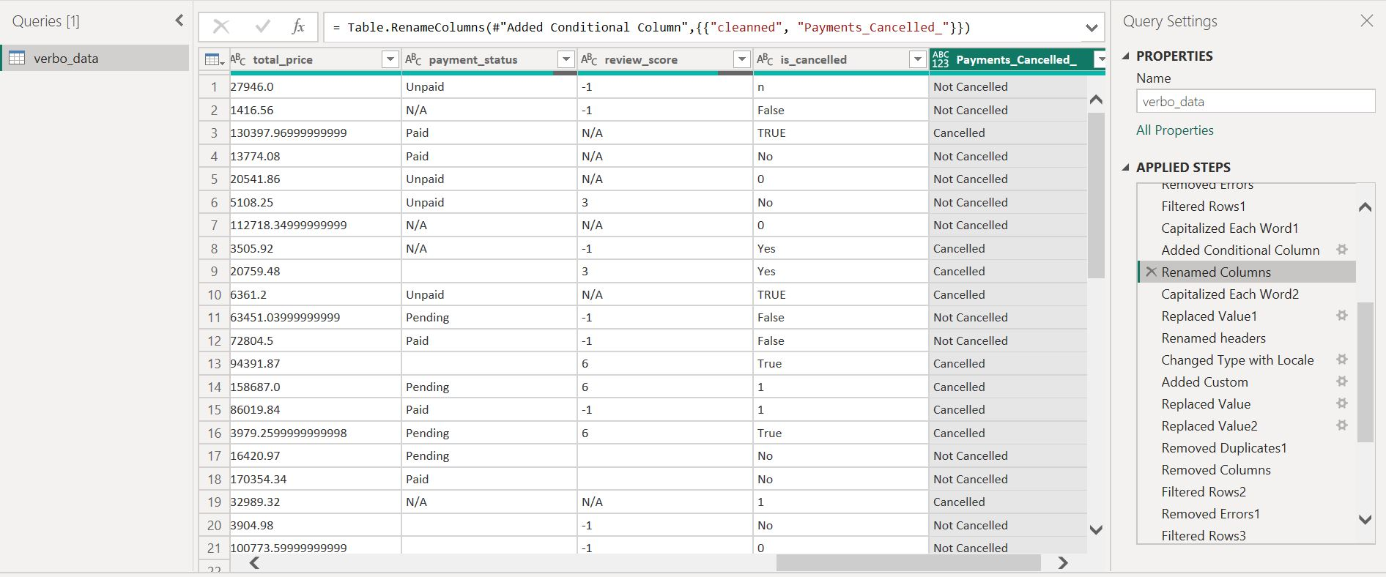

1.Added conditional column for is_cancelled column and Getting the output and renamed the column as payment_cancelled=

1.IF(Yes,TRUE,True,1)=Cancelled,

2.(No,False,0,n)=Not cancelled ,this are the condition i applied.

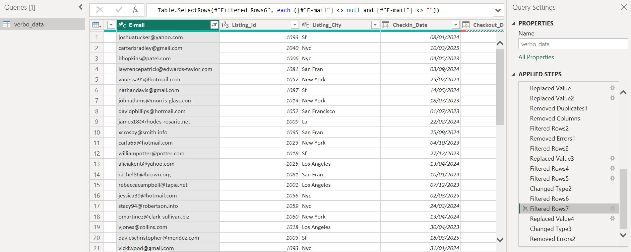

1.Removed Null values,blanks cells and errors in E-mail column.

2.Removed Duplicate e-mail Id.

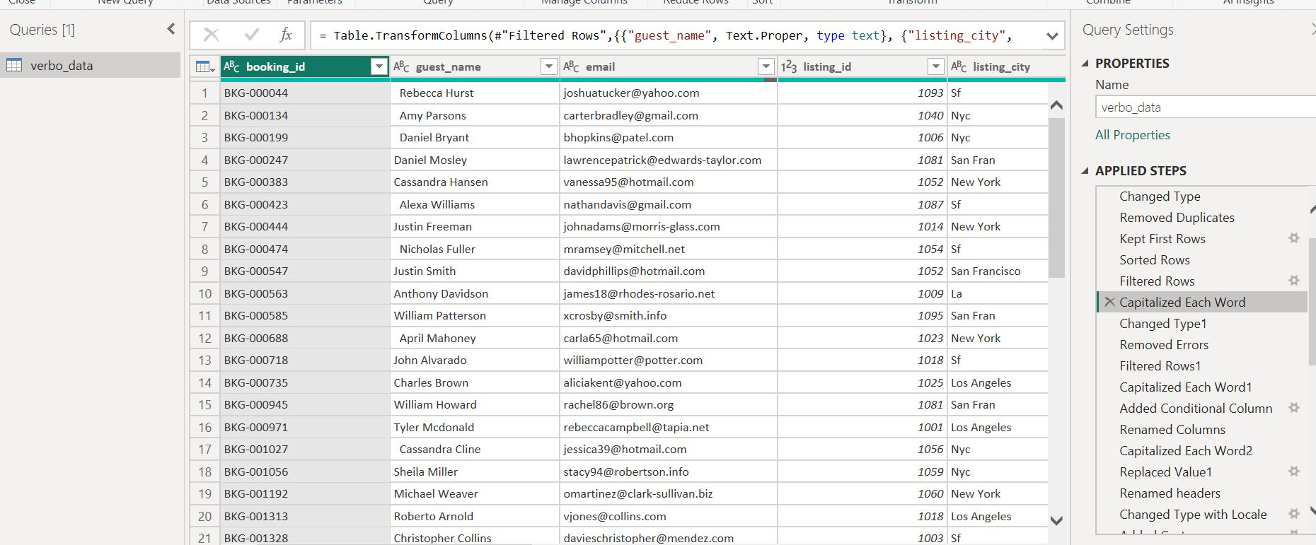

1.Sorted the rows ,filtered rows and capitalize the word in listing city column

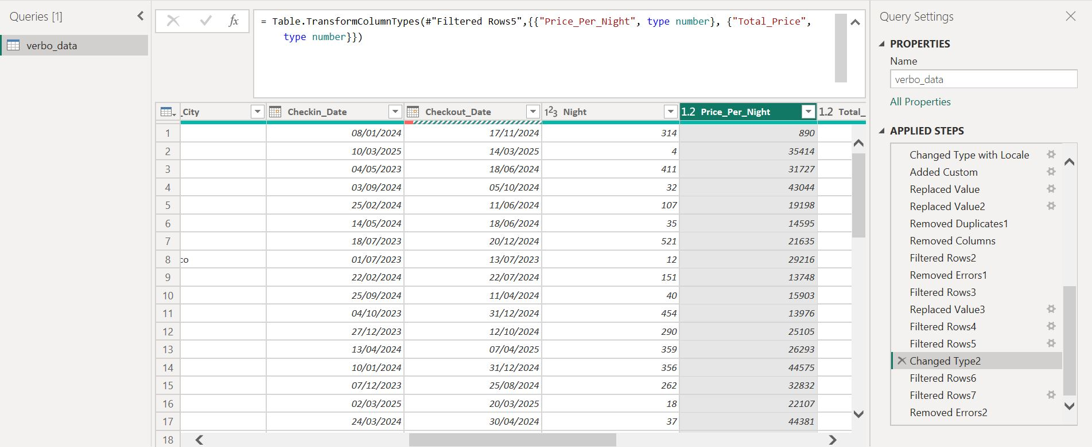

1.Removed the null values and empty spaces

2.Changed the data type text into whole number.